Proposal of Science Payload for Funding by the Science Mission Directorate

Harding University Flying Bison Rocket Team 2010-211

Table of Contents
- Introduction
- Hardware
  - Hardware choices
  - Tentative redundancy
- Methods
  - Sampling methods
  - Capture rates
- Circuitry
  - Wiring
  - Switches
  - Power requirements
  - Camera integration
- Rocket Integration
  - Payload structure
  - Fitting into airframe
  - Considerations for measuring data
- Recovery
  - Separation from rocket
  - Landing precautions
  - Tracking device
- Post Flight
  - Software
  - Analysis
- Future Considerations
  - Possible payload additions
  - Parachute precautions
  - Separating the nosecone
  - Testing
- Appendix
  - Wiring Diagrams
  - Payload Budget

- Introduction
We, Harding University, have decided to implement the payload suggested by the Science Mission Directorate for the 2010-2011 USLI competition. We will use a pod that separates from the rocket at an elevation of 2,500 feet during the descent. This pod will take data as soon as apogee is reached, and continue taking data until ten minutes after landing. We intend to measure temperature, pressure, relative humidity, solar irradiance, and ultraviolet radiation. In addition to this, we will take three pictures during descent and three pictures after the pod has come to a safe landing.
- Hardware
To complete the required tasks, we will use an array of hardware. The table below is a quick look at the proposed choices for this hardware.
Function | Part Number
Ultraviolet radiation and solar irradiance sensor | Osioptoelectronics UDT-455 UV/LN
Pressure Sensor | Honeywell ASD015A24R
Temperature Sensor | National Semiconductor LM50CIM3
Relative Humidity | Honeywell HIH 4000
Camera | Innovage Mini-Digital Camera
Microcontroller | Atmel ATMEGA 32
Altimeter | Perfect Flight MAWD

We will integrate this hardware on a total of three circuit boards within the pod. For more specifics on the less significant circuit components, see the wiring diagrams to follow. Currently we have not implemented a plan for redundancy but we are looking into the possibility of building our own instrumentation with simple circuit components to test and compare the accuracy and precision of some different methods and hardware. One example is designing Wheatstone bridges with different thermistors to test the reliability of these circuit components. These sensors would be low cost and serve as a back-up for our main sensors.
- Methods
We will be using the sensors detailed above to take analog measurements that will be converted into digital and stored in our memory. The microprocessor can take a reading from one of the sensors at N Hz. This means that the sample rate for each sensor will be N divided by the number of sensors. The minimum sampling rate specified in the project guidelines was a minimum sampling rate of one measurement every 5 seconds, equivalent to .2 Hz. We will calibrate our circuitry to take measurements every three seconds during the descent and every thirty seconds on the ground.
As soon as apogee is reached and the drogue parachute is deployed, data will begin to be taken from the sensors every three seconds. As the rocket reaches an altitude of 2,500 feet, the pod will be deployed. As this happens, a pin will be pulled to activate the camera. After a delay, the camera will take three pictures. We will place a switch on two of the four feet of the payload pod so that as soon as one switch is depressed, the second round of pictures will be taken, and data from the sensors will begin to be taken every thirty seconds.

- Circuitry

The wiring diagrams for all of the circuitry that is encompassed in our payload pod can be seen in the appendix of this proposal. We will use the flight computers to initialize the data capture at apogee and a pull switch to initialize the camera circuitry as the payload is deployed during descent. As stated previously, we will use switches on the feet of the pod to continue to take data and take pictures after the payload has touched down.
To meet our power requirements, we have implemented four 9-volt batteries into the payload. We will use a 555 timer to take pictures. We have listed a tentative camera option above, but we are continuing to research camera options.

- Rocket Integration

We will use the payload structure seen below.

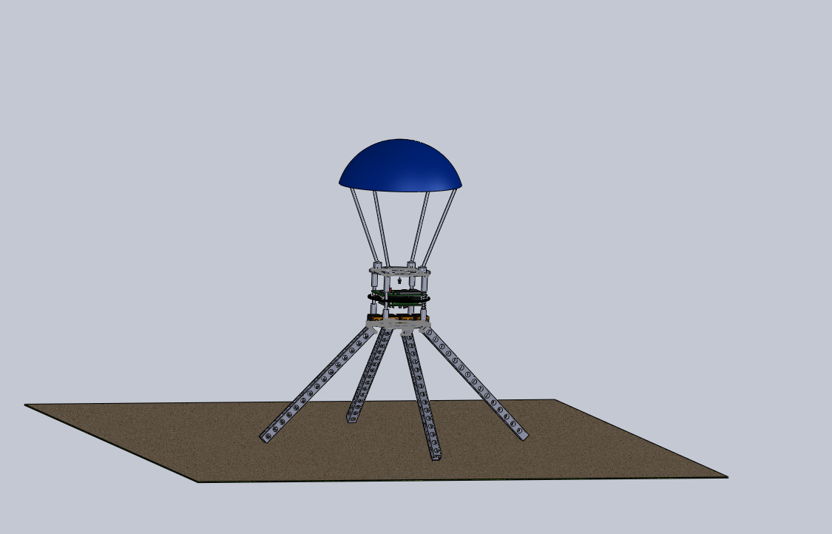

It consists of a main payload section with a top deck and a bottom deck. The power supply is located on the lower deck, and the camera hangs from the upper deck. The camera is free to swing in any direction and contains a weight. We will use gravity to keep our camera in the correct orientation if our payload lands on an uneven surface. Between these two decks is the circuitry deck. One board will be mounted on the bottom and the other two will be mounted above. The four legs of the pod will be spring loaded so that they will open upon separation from the rocket. Our current plan is to use static rods to connect the parachute to the pod. These rods will be connected with a ball and socket joint at the top deck of the payload. This allows the parachute to move more freely. These joints will only allow the rods to move somewhat, and will keep the parachute above the payload upon touchdown. This will ensure that the parachute will not block the camera or irradiance and radiation sensors while data is continually measured on the ground.
The payload will be placed in the nosecone as seen below.

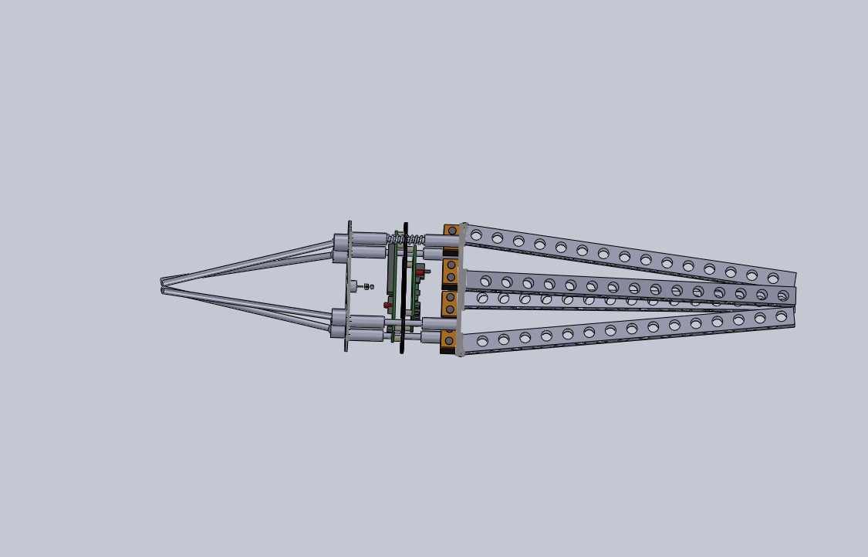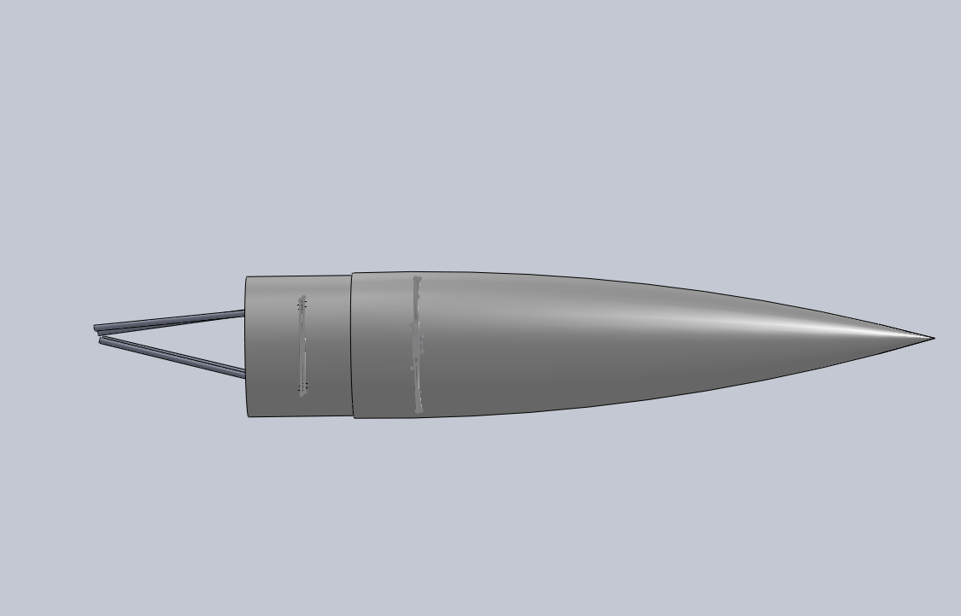

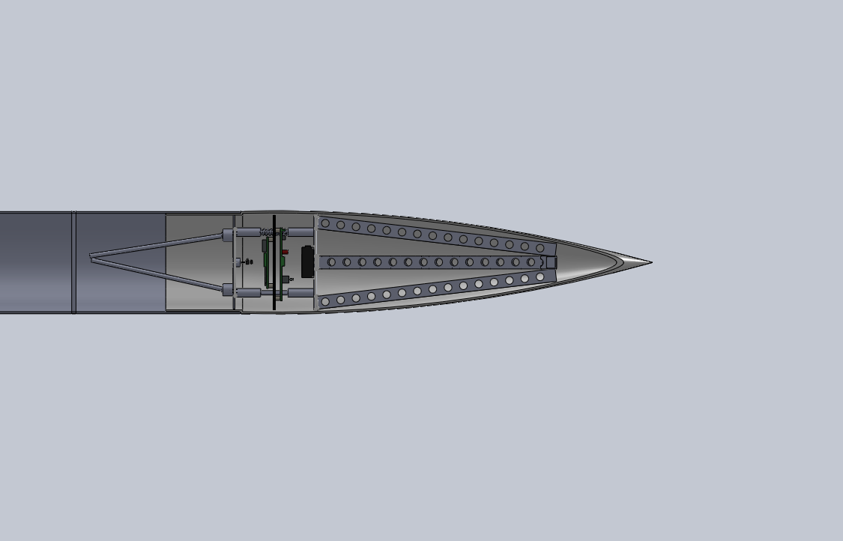

A small hole will be drilled out of the side of the nosecone and main airframe to allow the sensors to take accurate data. Also, the light sensitive sensors will be directed out of this hole.

- Recovery

At 2,500 feet of elevation, the altimeter included in the payload will set off directional
charges located at the end of the nosecone. The blast will leave the payload exposed and it will fall from the rocket. This action will cause the parachute to deploy.

To help protect the payload from the shock of landing, we plan to implement a damping
system to the circuitry deck. We will use a spring above and below the deck on each of the four supports. A rough idea of this is illustrated on just one of the four supports in the picture below.

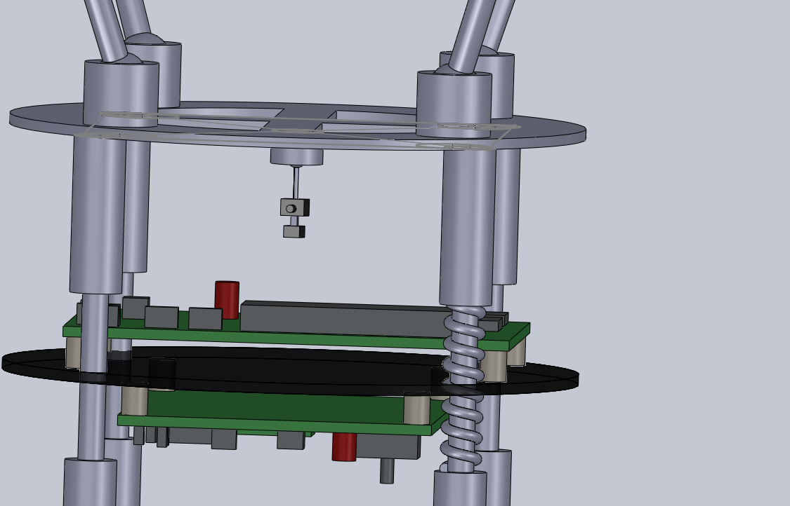

We will use a GPS tracking system to locate our payload. The exact system that we will use has not been decided upon, but this decision will be made before the PDR is completed.

- Post Flight

We will use the RockOn! software package to analyze our data after the flight is completed. We will retrieve this data from the payload via USB ports. We are continuing to research other software options. We plan to plot our data as a function of altitude.

- Future Considerations

There are still some questions to answer before the PDR is completed. We are still
investigating the possibility of also including some additional instrumentation created completely in our labs.
We are also addressing the problem of the parachute on our payload. An additional solution we are continuing to research is the possibility of having the parachute connected to regular parachute lines, and having static rods that the parachute will land on far above the payload, but will not affect the parachute during the descent.
We also continue to work on plans to protect our payload during the sepearation of the nosecone. We hope to have a good seal around the bottom deck of the payload and the nose cone so that the pressure from the separation charge is directed completely out on the nosecone. We are thinking of using the static rods mentioned in the paragraph above to stay in contact with the forward bulkhead to keep all of the force on the rods of the payload section during the separation process.
We intend to test our payload with multiple drop tests, test flights, and laboratory testing.

- Appendix
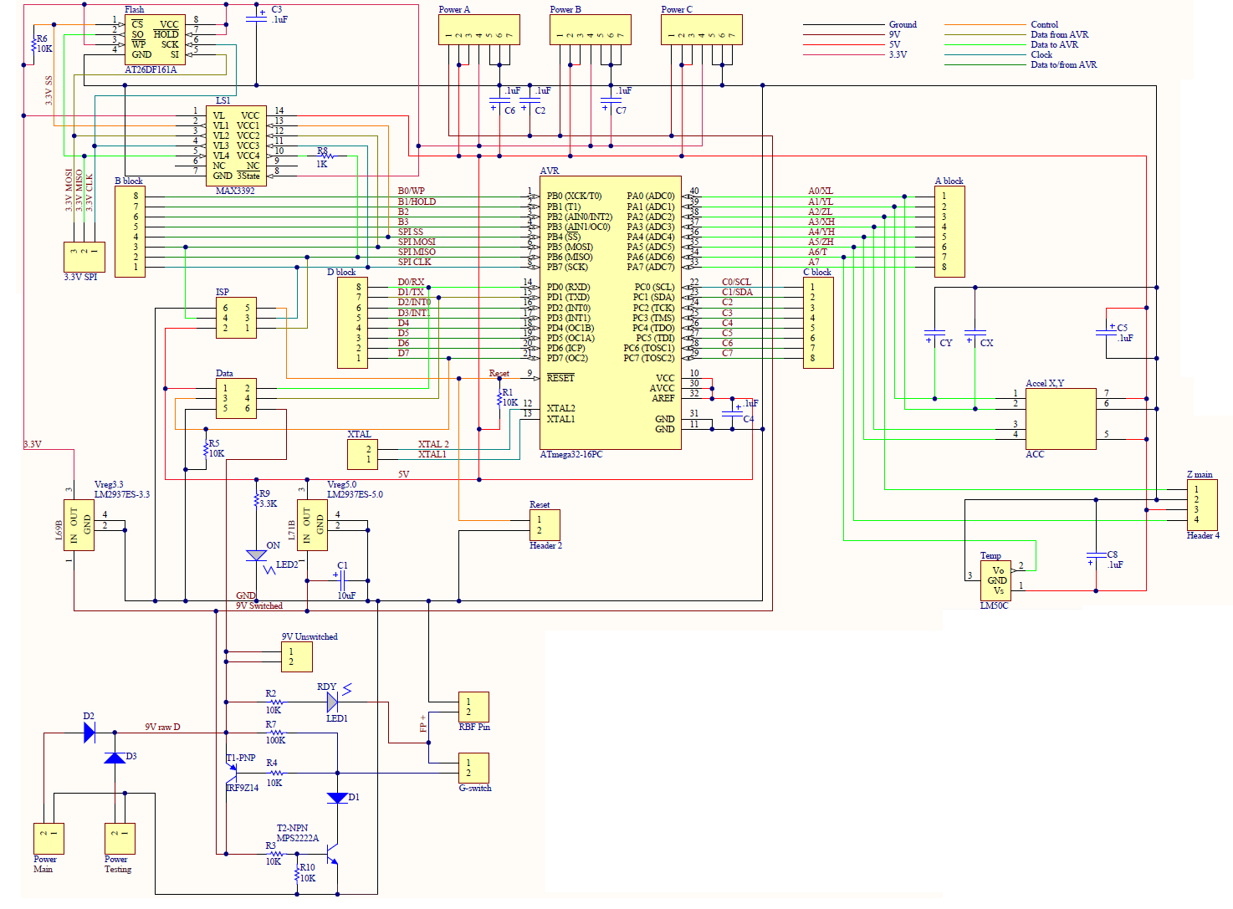
Wiring Diagrams:

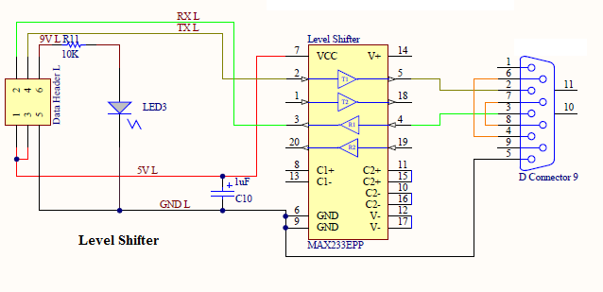

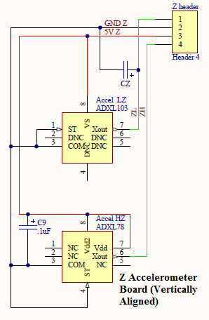
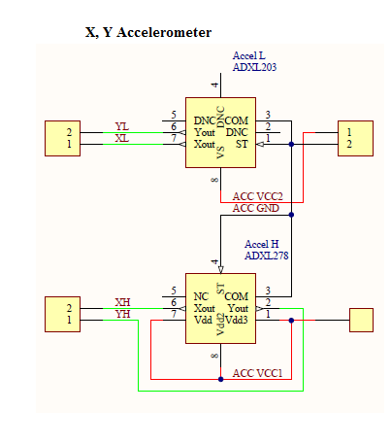

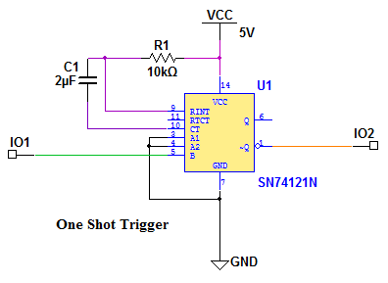
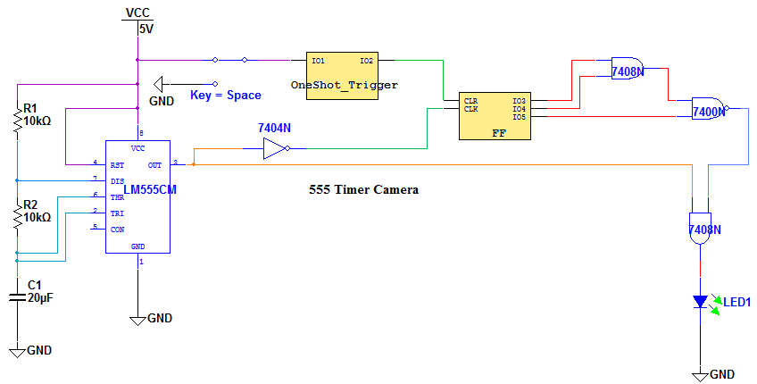

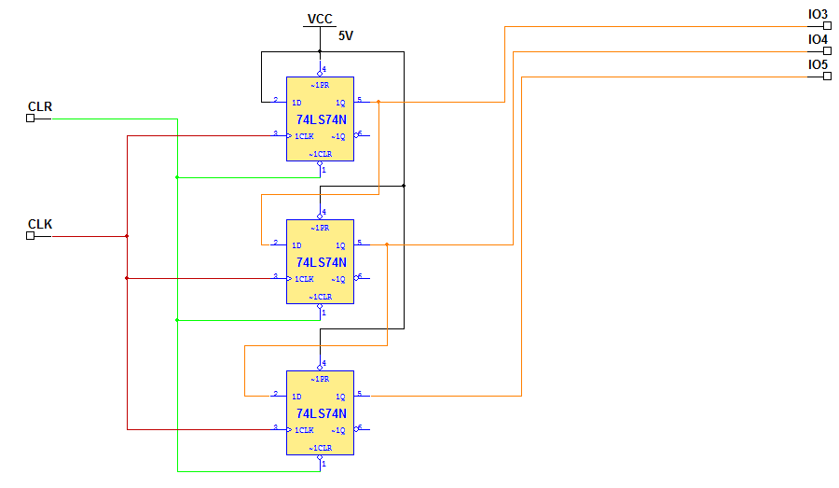
Budget:
Item | Price
Materials for Payload Structure | < $50
Power Supply | $8
Innovage Mini-Digital Camera | $7.75
SkyAngle Classic 32 | $41.25
Humidity Sensor | $18.75
Temperature Sensor | $1.11
Pressure Sensor | $49.07
Ultraviolet radiation/ Solar Irradiance Sensor | Currently Unavailable (around $80)
Microcontroller | $12.00
Altimeter | $99.95
Additional Circuit Components | <$10
TOTAL | <$377.88

